Laboratory work 3
Drawing animations in Matplotlib

Task
Develop a program that builds animation according to the option, save it in gif format. The options are set according to the student number:
6. A rectangle with rounded edges moving along a sine wave;

The animation was implemented using matplotlib’s animation module. A figure and axes were created with specific dimensions and resolution. A rectangle with rounded edges was drawn using FancyBboxPatch, which allows specifying rounded corners via the boxstyle="round" option. The rectangle’s width and height were set to 1.5 and 1 units, respectively.
The animation is controlled by the FuncAnimation function. An init function sets the rectangle to its initial position on the axes. The animate function moves the rectangle along a sine wave. The horizontal movement is linear (x = 0.05 * i), while the vertical position follows the sine wave (y = 5 + 2 * np.sin(0.5 * x * π)). This produces smooth oscillatory motion along the y-axis as the rectangle progresses horizontally.
The animation consists of 200 frames with a frame interval of 50 milliseconds. The blit=True option was used to optimize rendering by updating only the elements that change, improving performance. The FuncAnimation object manages frame updates and ensures the rectangle moves continuously along the sine path.
The animation was saved in GIF format using the pillow writer as "rounded_rectangle_sine.gif". The final visualization demonstrates the rectangle smoothly oscillating along a sine wave path. This animation serves as an example of combining mathematical functions with visual elements to produce dynamic graphical representations, and it can be extended to other parametric motion visualizations.
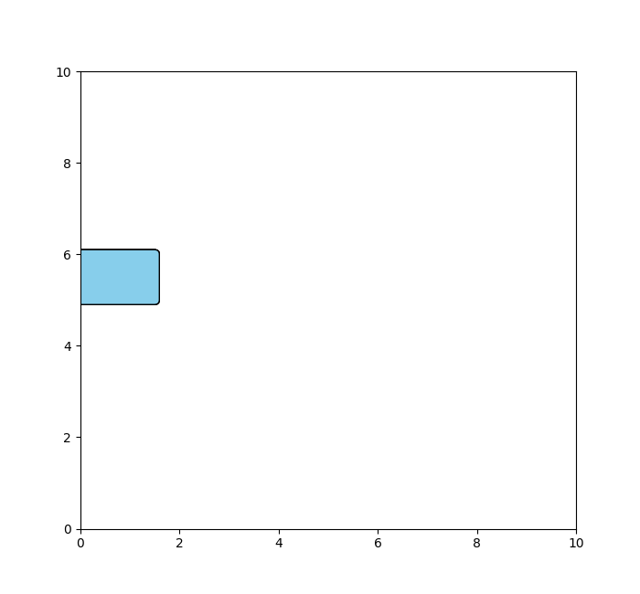
Figure 1 – Results of animation

